**CPU PERFORMANCE USING C**

**AIM:**

To write a C program to implement CPU performance using C.  
  
  
  
  
  
**ALGORITHM:**  
  
  
1)      Store  
the remainder when the number is divided by 8 in an array.  
  
  
2)      Divide  
the number by 8 now  
  
  
3)      Repeat  
the above two steps until the number is not equal to 0.  
  
  
4)      Print  
the array in reverse order now.

**PROGRAM:**

#include <stdio.h>

int main(){

float c;

int p,p1,i;

float cpu[15];

float cpi,ct,max,cr;

int n;

printf("Enter the cpu performance:");

scanf("%d",&n);

for(i=0;i<=4;i++)

{

cpu[5]=0;

}

printf("\nEnter the no of processor:");

scanf("%d",&p);

//Declaration

p1=p;

for(i=0;i<p;i++)

{

printf("\nEnter the cycles per instruction of processsor:");

scanf("%f",&cpi);

printf("\n Enter the clockrate in GHz:");

scanf("%f",&cr);

ct=1000*cpi/cr;

printf("The CPU time is: %f",ct);

cpu[i]=ct;

}

max=cpu[0];

for(i=0;i<p1;i++)

{

if(cpu[i]<=max)

max=cpu[i];

}

printf("\nThe processor has lowest Execution time is: %f ", max);

return 0;

}

**INPUT & OUTPUT:**

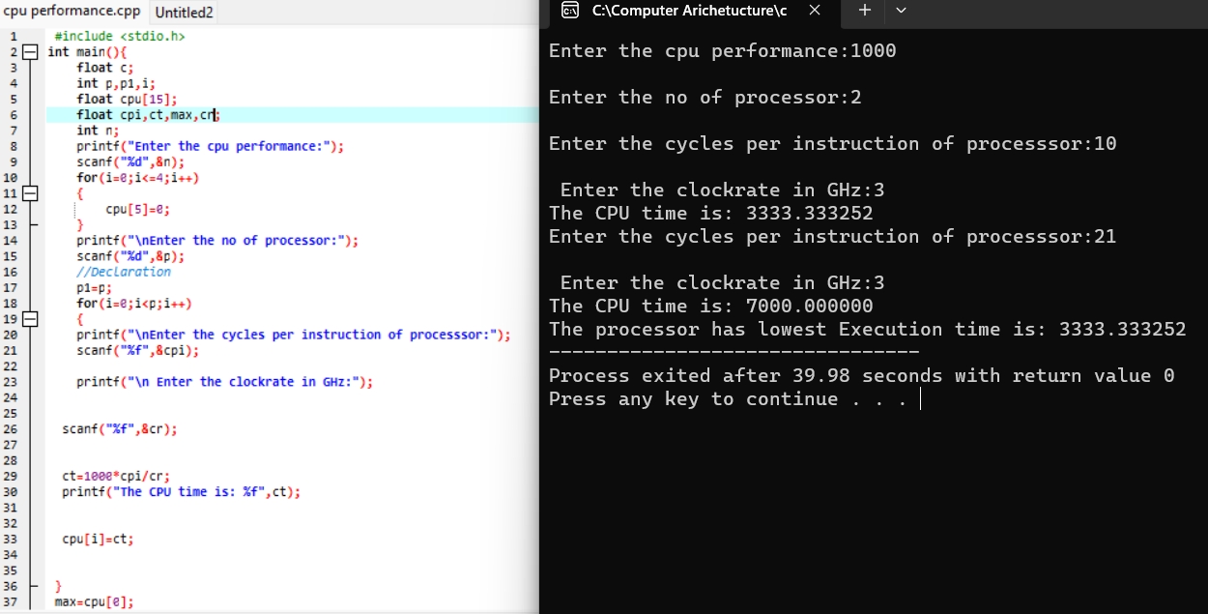

**RESULT:**

Thus we can write the program for CPU performance in DEV C++.